Solution approach for Problem 2:

FirstName and LastName TextField must not be null and contain alphanumeric characters. Solution is by checking the string for alphabetic and numeric characters using the .match(<regex>) function. Then, the HTML document is changed by appending an image to the end of the element chosen which is firstName and lastName.

Attached is the picture of the solution for appending images to the end of elements(firstName & lastName).



Attached below is the picture of the validation for alphanumeric characters.

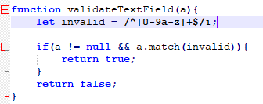

For Gender and State, the selector has to be used and if nothing is selected by the user, it will output an error image. Thus, the solution is by adding a default selector which is “---” when the page is launched. If the user does not change it, it will stay as that string. Thus, in JS, we can only check whether it has been changed or not, if it has not changed, output error image.

Attached below is the solution for appending images to the end of elements(gender & state).

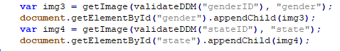

Attached below is the image of the Drop Down Menu Validation.

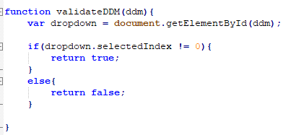

The JS function will only run if the button is clicked, thus we implement an onClick function on the button that runs the script as shown below.



Attached below is the example of the website validation system when all input is correct.

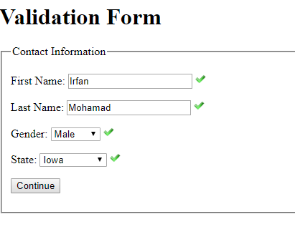

Attached below is the example of the website validation system when 3 input is correct.

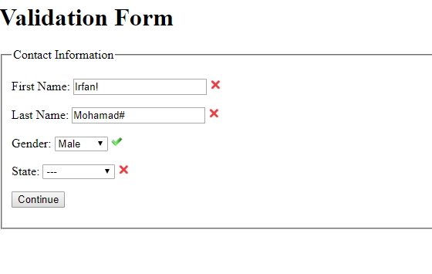

Solution for Problem 3:

The textfield for email is split into 3 parts using the special characters ‘@’ for the first split, and ‘.’ for the second split. Then, we check the substrings after the string is split. If these strings contain any non-alphabetical character, the error image is added to the HTML file via appending it.

Then, the phone number formatting is check by the length first. The length can only be either 10 or 12. If it is 10, there should be no hyphens and the string should only contain numerical characters. If it is 12, we check the 4th and 8th character; these characters should be hyphens, if they are not.

The Address is checked where all characters are alphabetical. We do not accept spaces or numbers. Then, the string is split at the comma(,). After it is split, we check the second substring for the state. The length of this substring should be only 2. We do not need to check the length of the first substring for now. Then, it is passed through the validation after the Submit button is pressed.

Attached below is the example of the website validation system when all input is correct.

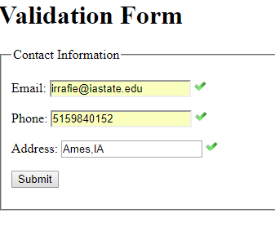

Attached below is the example of the system for phones numbers formatted with hyphens.

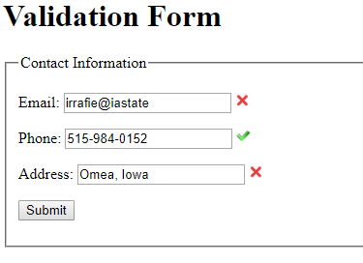

Attached below is the example of the website validation system when all input is incorrect.

